Use Case 1

Step 1. User opens the app.

Step 2. The app shows the UI.

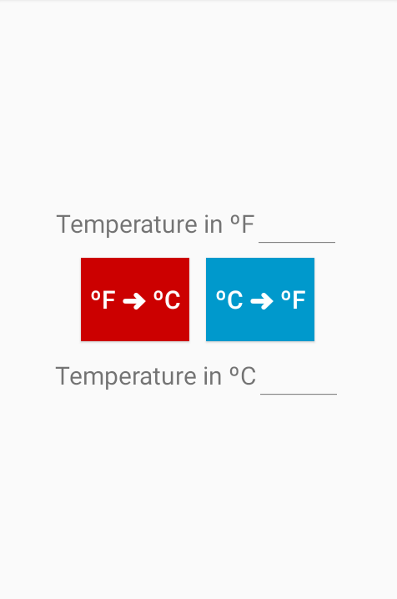

Step 3. User inputs a temperature value in Fahrenheit and click the convert (red) button.

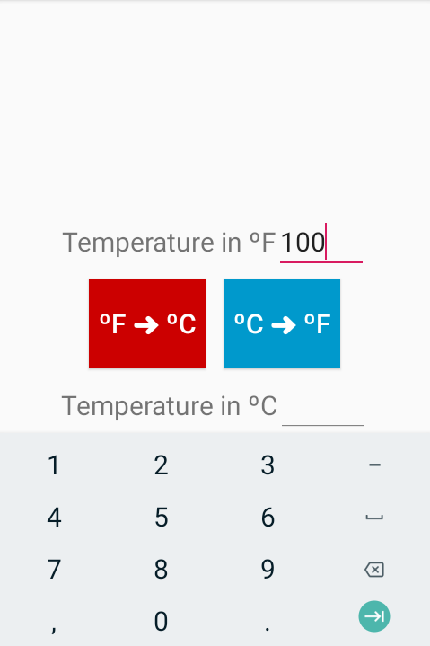

Step 4. The system converts the temperature into Celsius and show the result.

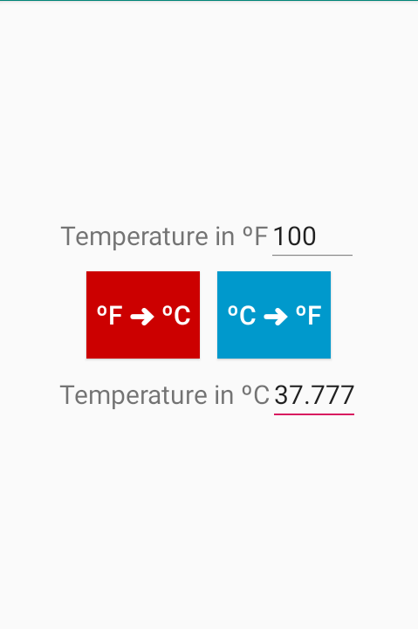

Use Case 2

Step 1. User opens the app.

Step 2. The app shows the UI.



Step 3. User input a temperature value in Celsius and click the convert (blue) button.

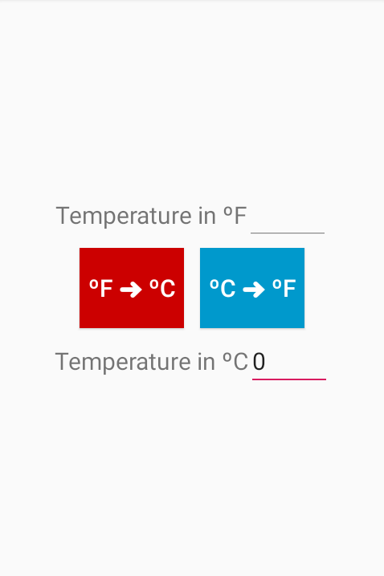

Step 4. The system converts the temperature into Fahrenheit and shows the result.

